 Admin Guidelines

1. Click on the Register button on the top right side of your screen 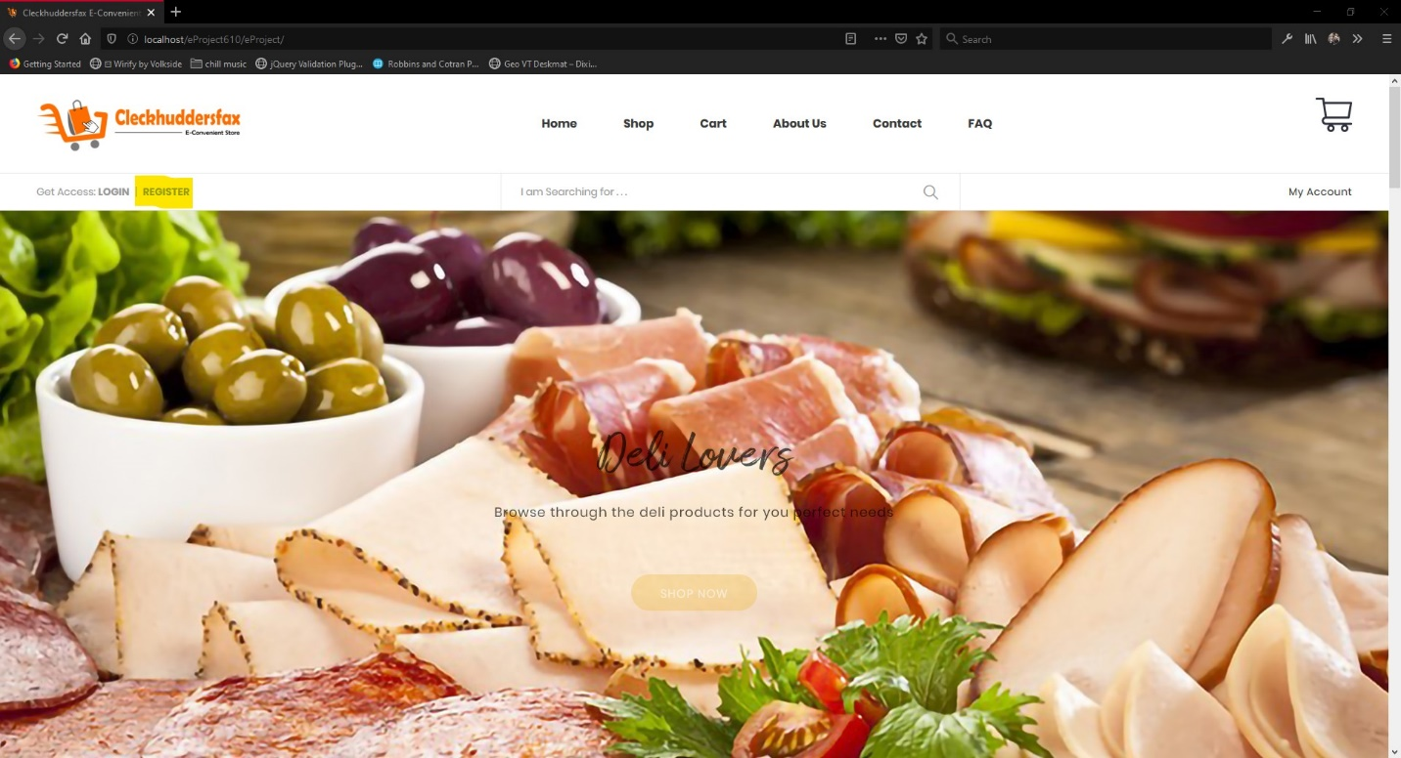
2. You will be redirected to the register page fill out he form and make sure to choose admin from the drop-down menu
3. If the admin dropdown does not appear it means that the website has already has an admin registered
4. After you fill out the form check the terms and condition box and click on register 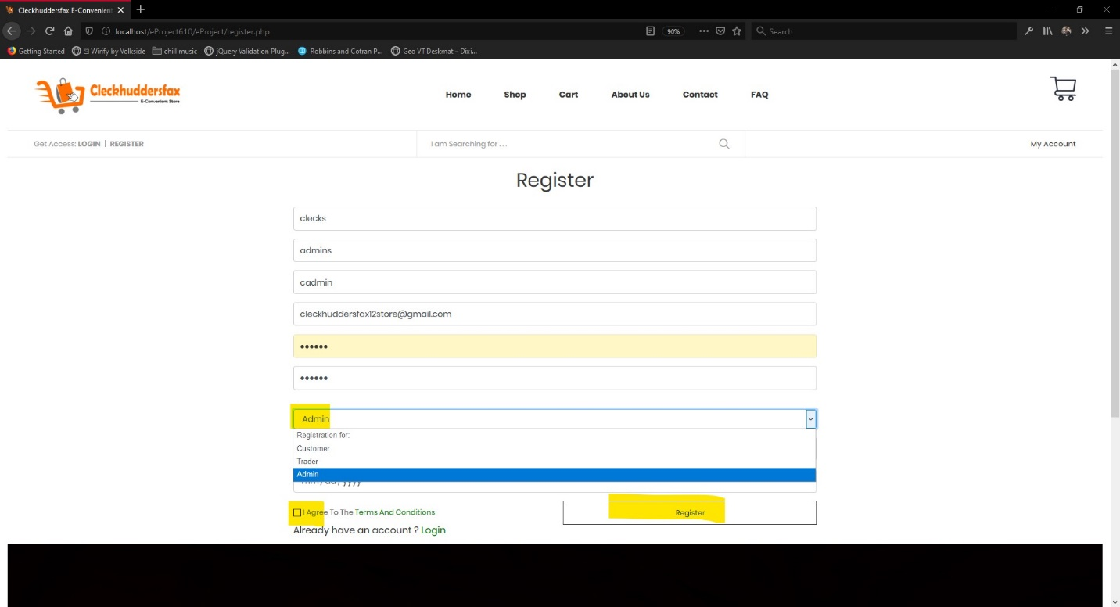
5. The following message will appear and an email will be sent to your email address that you just entered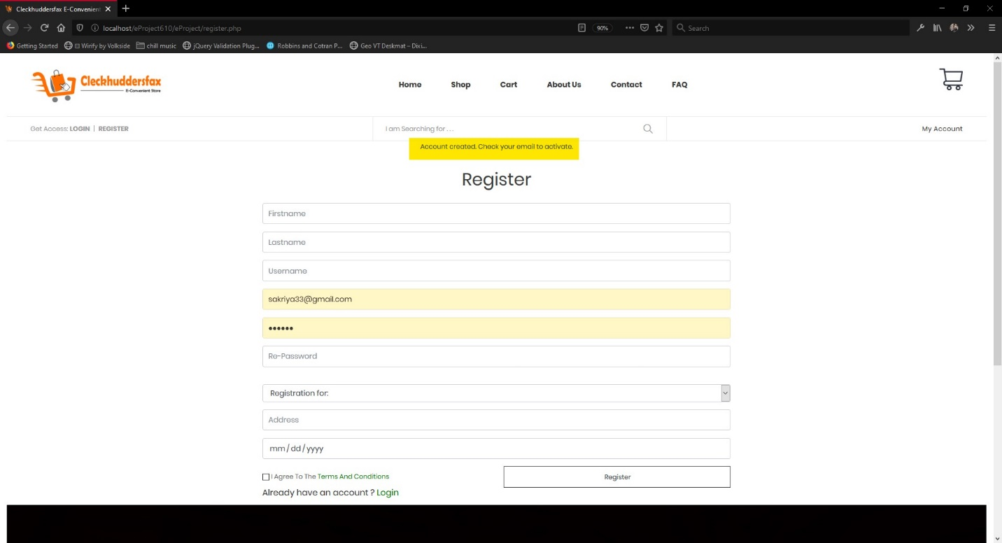
6. Click on link given in the mail then your email will be verified 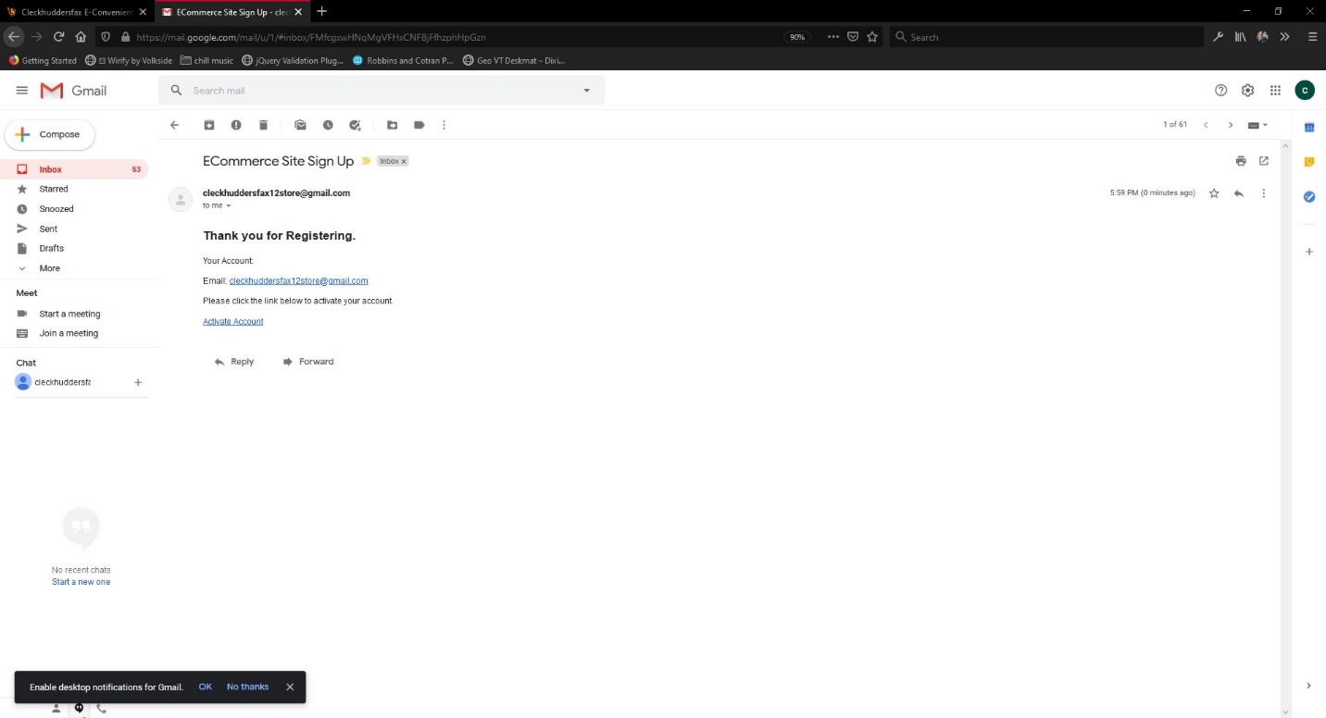
7. After that you will be redirected to this page with the following message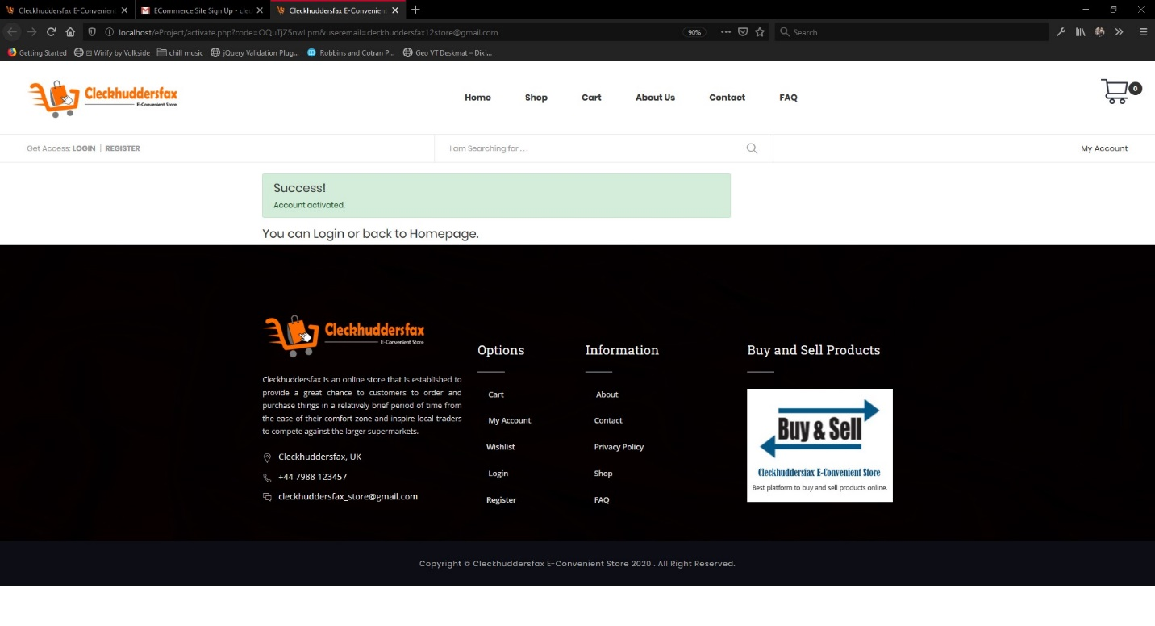
8. Enter the details that you filled out in step 2 in the login page 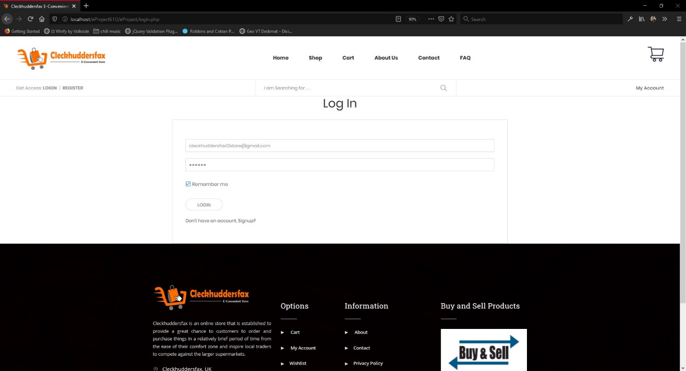
9. Now you will be redirected to the php Dashboard as in the image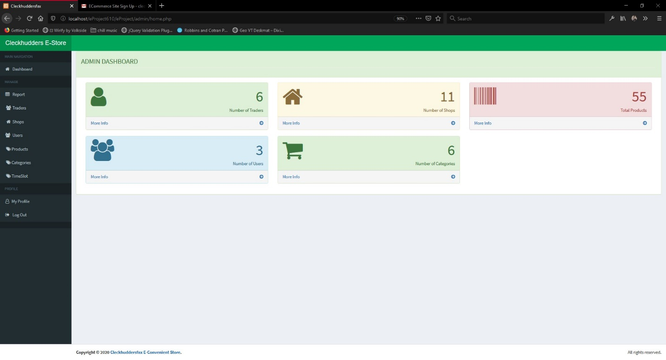
10. You can find the trader tab where you can activate and deactivate a trader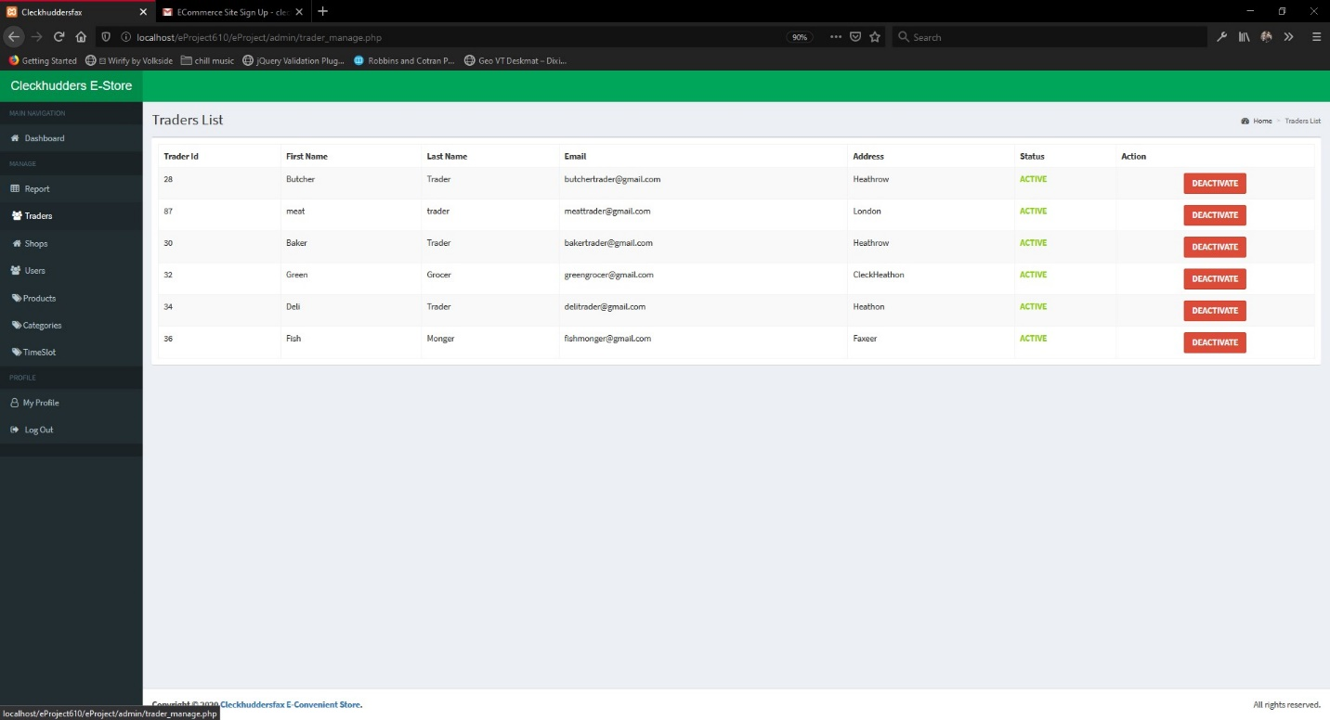
11. You can find the Shops tab where you can activate and deactivate a shop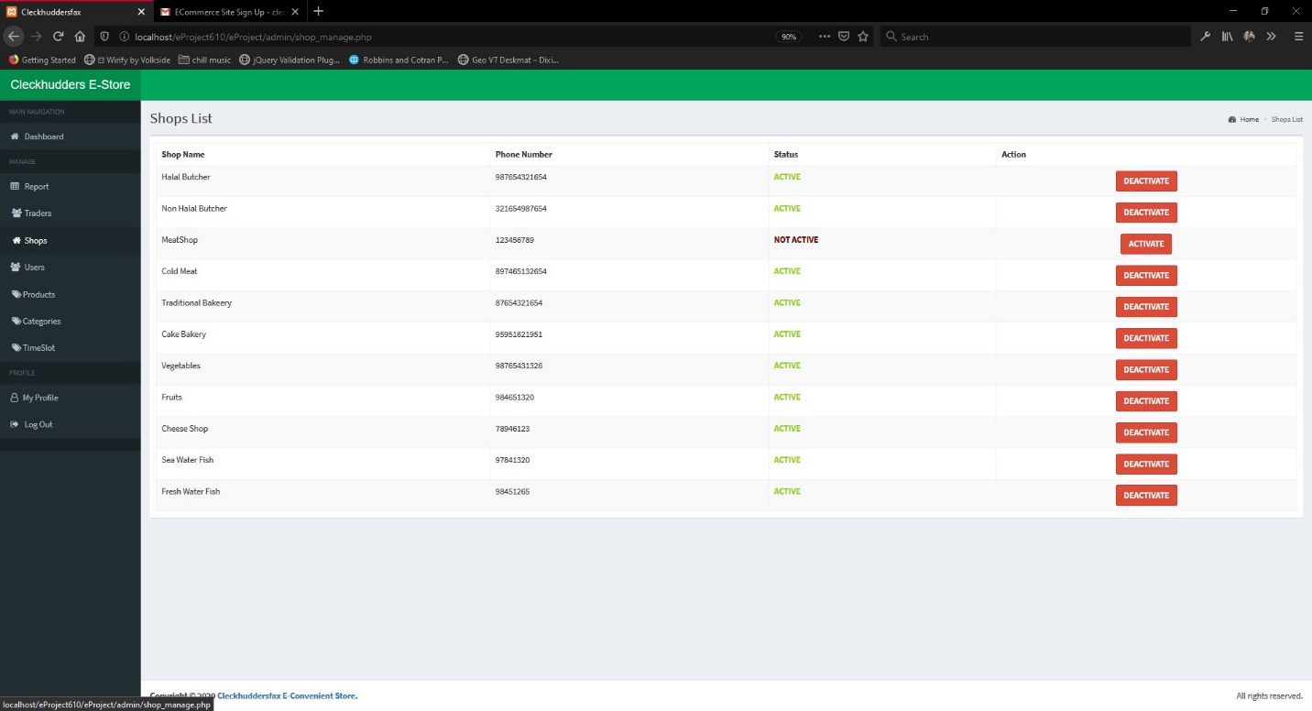
12. You can find a User’s tab where all the customers of the website will be shown along with activation and deactivation function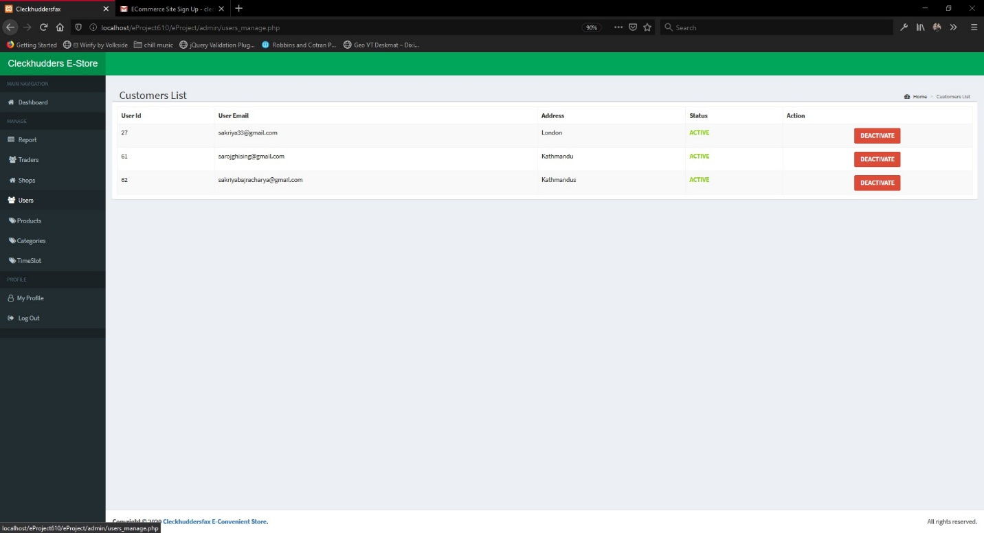
13. You can also find the products tab with all the details
14. Also, a category tab where you can add a category is shown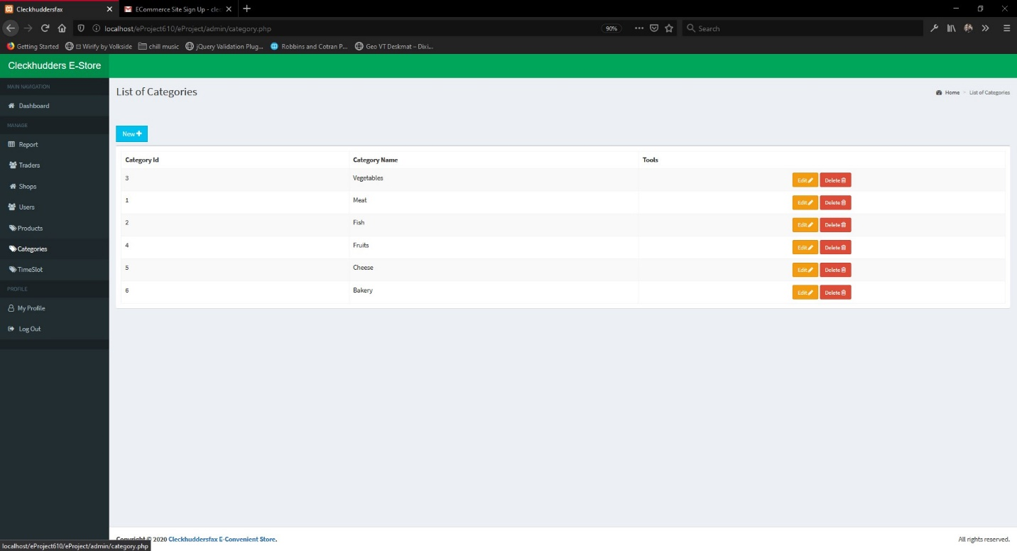
15. You can also view the collection slots chosen by the customer for their delivery times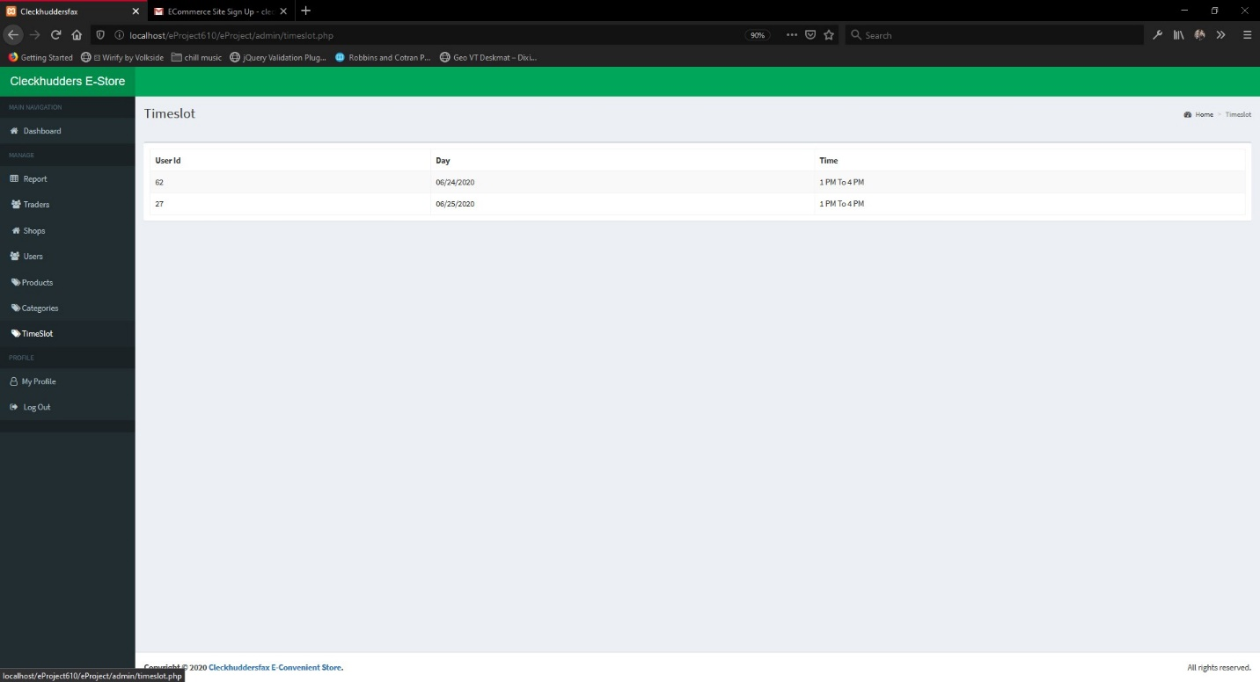
16. Also, my profile is added where you can view and edit you profile details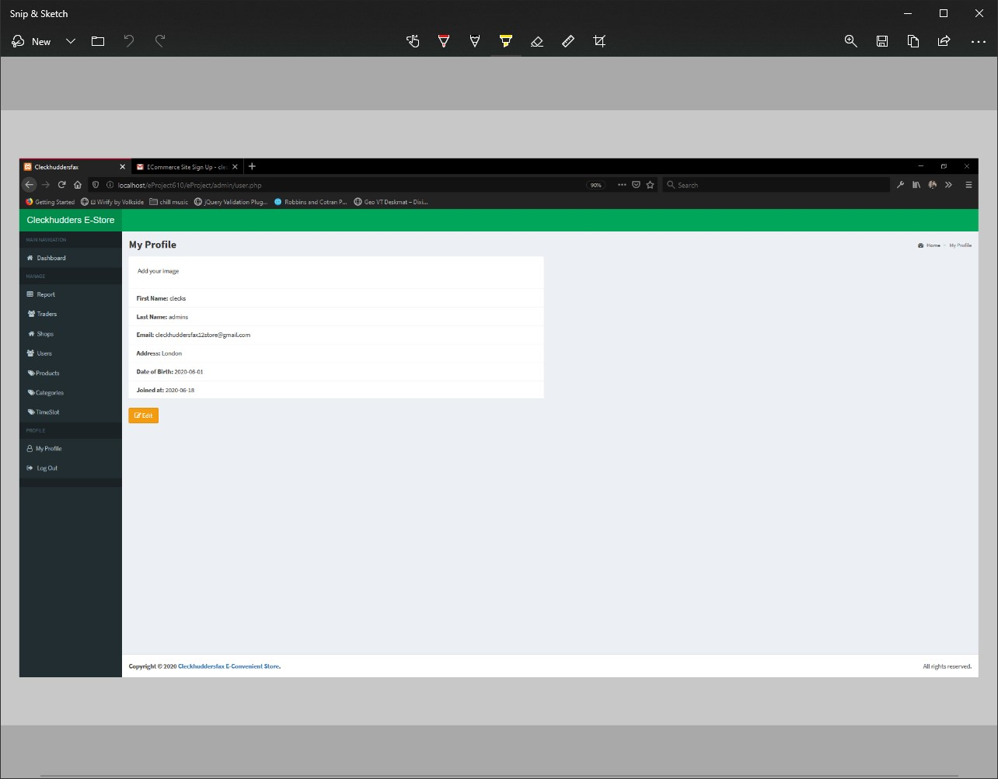
17. You can then click in the Reports tab to open the apex application login page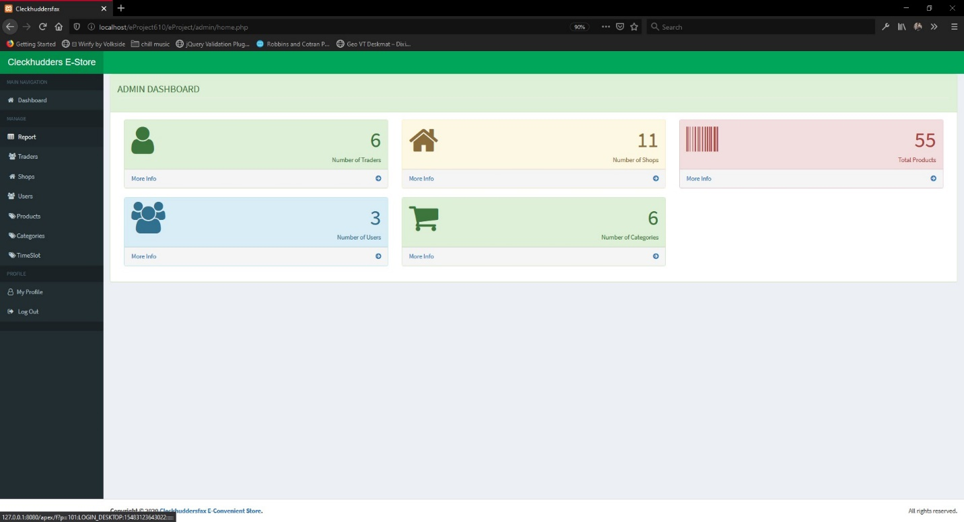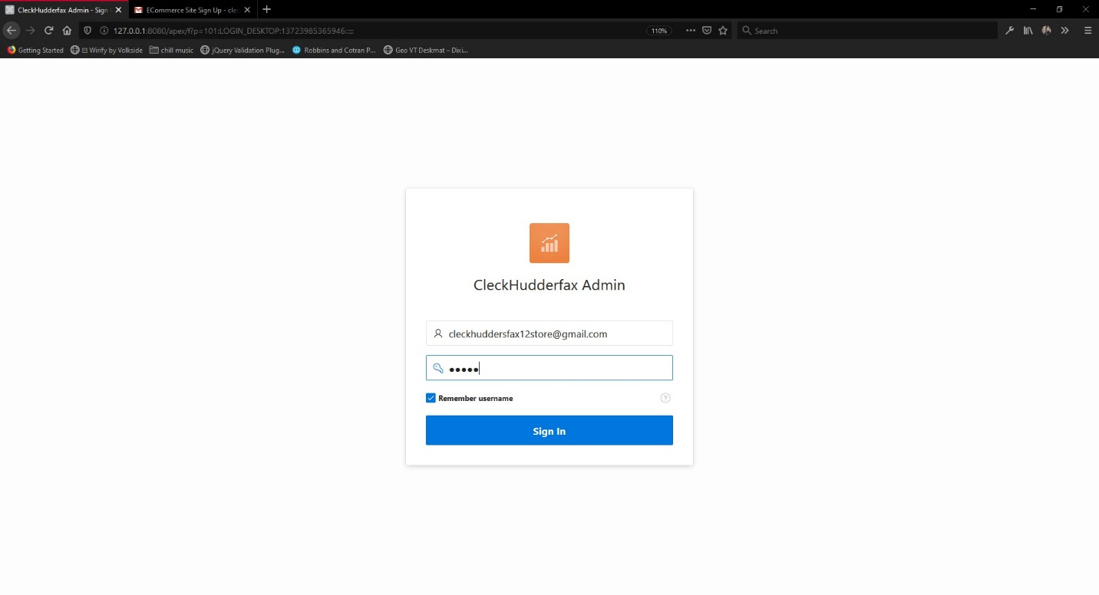
18. Then you are redirected to the apex application dashboard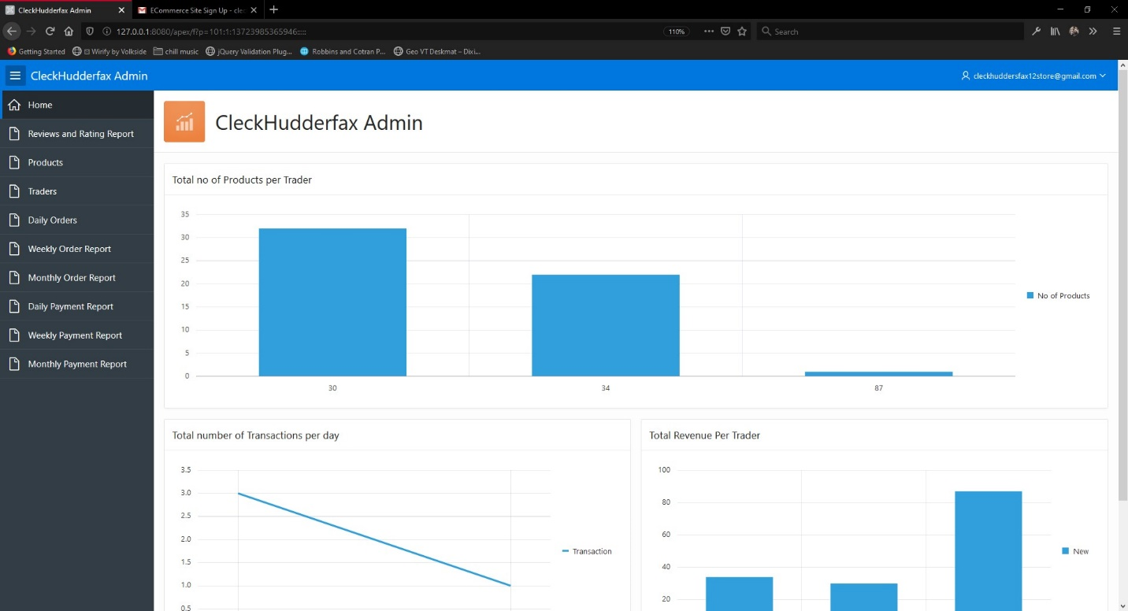
19. Here you can find various reports  
    Products report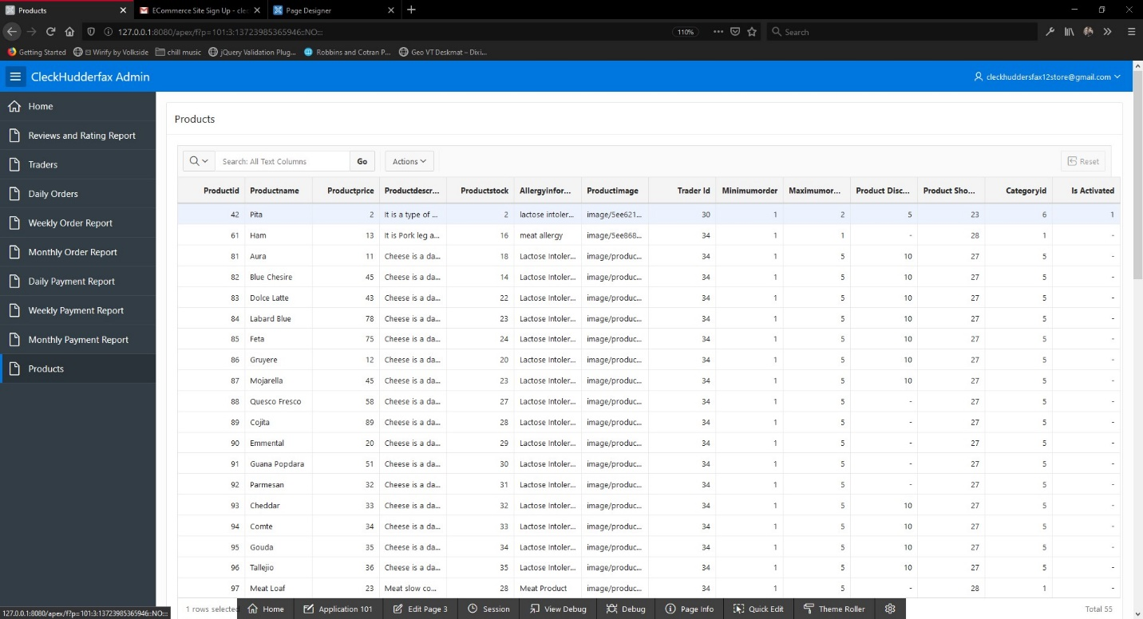Monthly Payment Report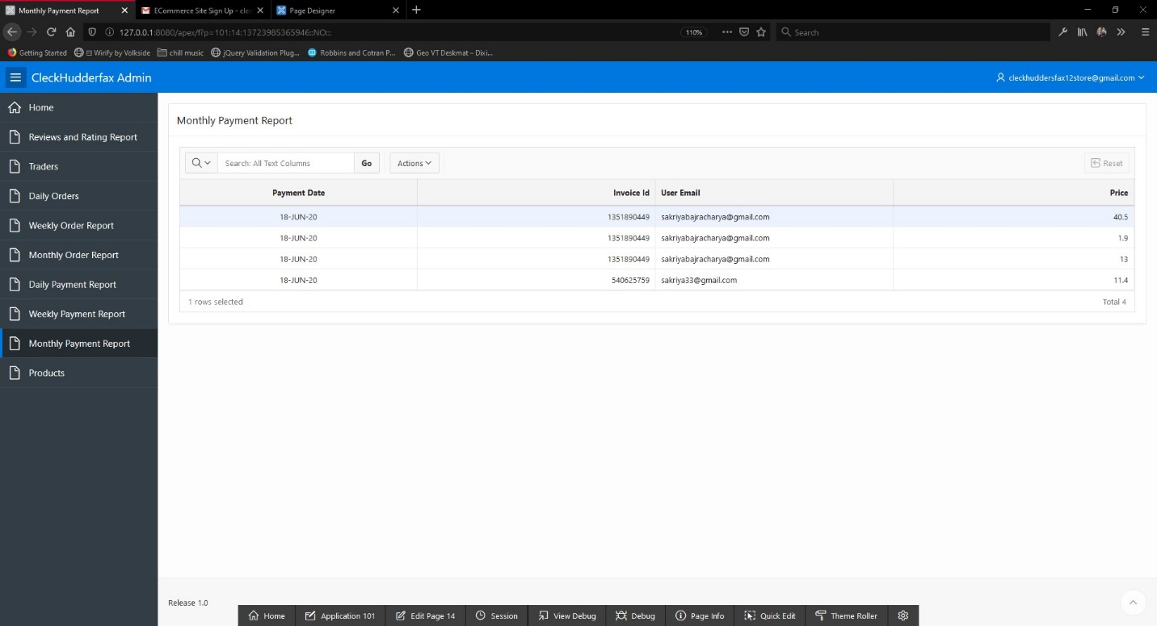

Weekly Payment Report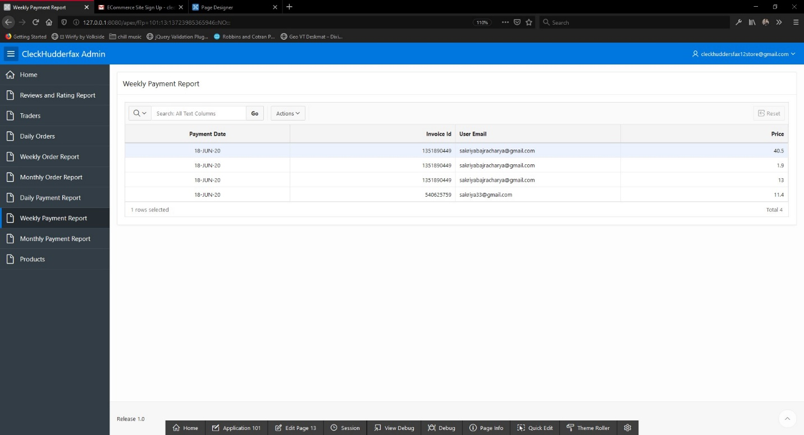Daily Payment Report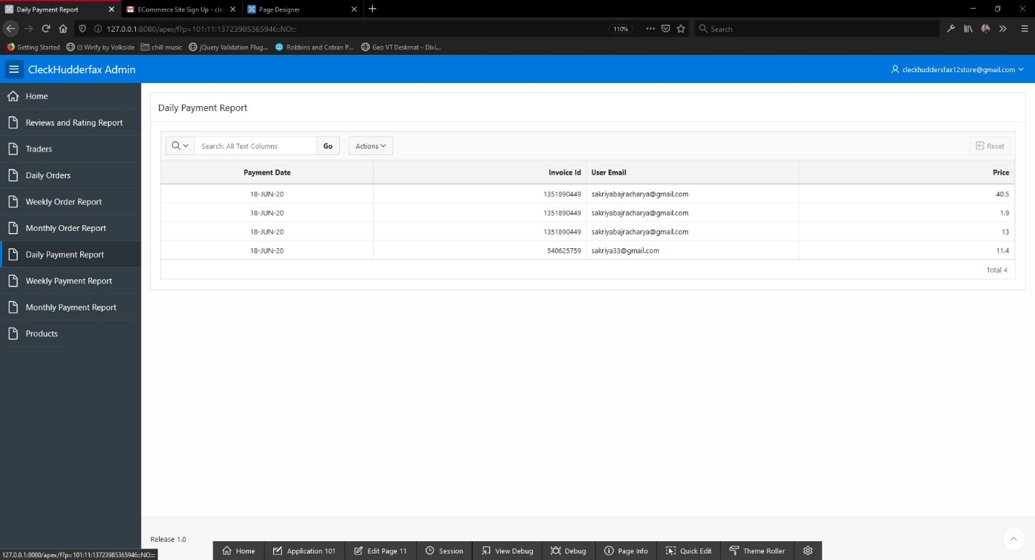

Monthly Order Report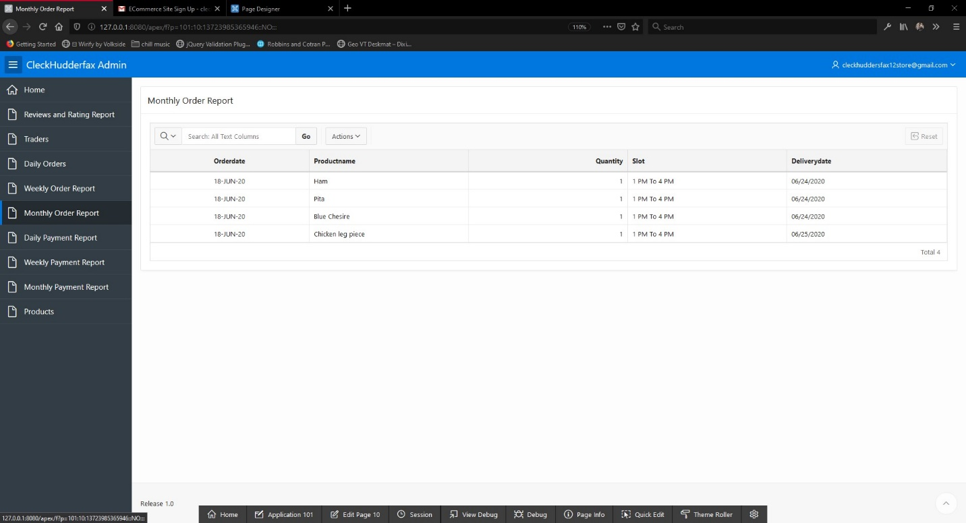Weekly Order Report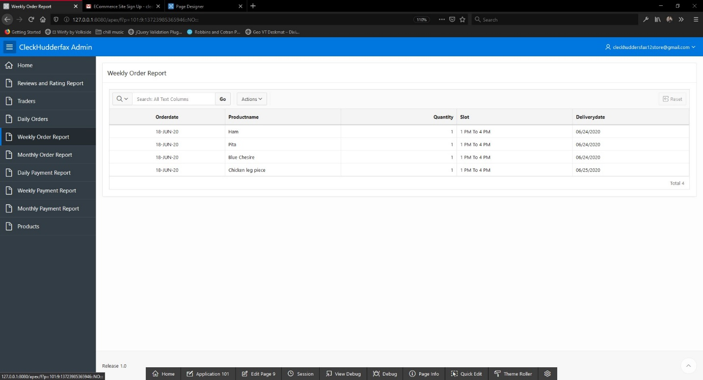

Daily Order Report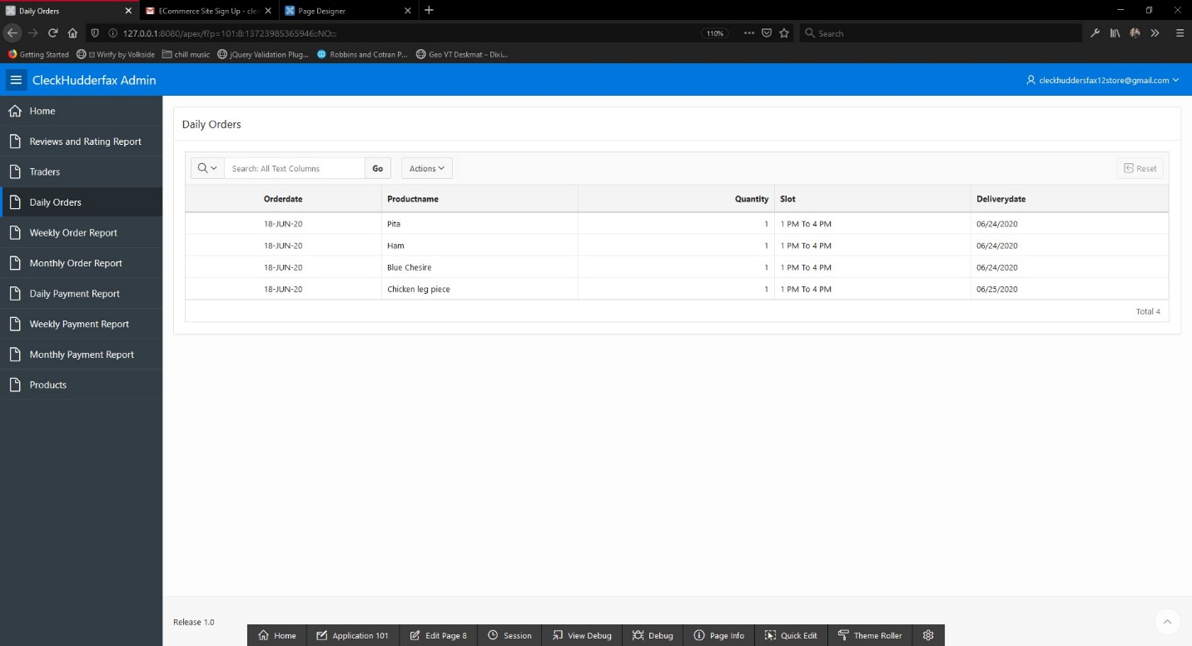

Traders Registered in the website report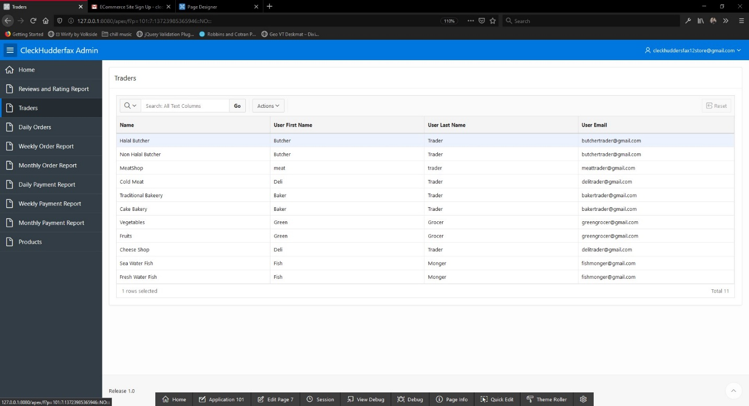Rating and Reviews of the Products report